|  |  |
| --- | --- |
| **YEAR 8** | **Heat (Thermal) Energy** |

|  |  |  |
| --- | --- | --- |
| **Learning Intentions** | | **Success Criteria** |
| Understand heat (thermal) energy. | * Describe thermal energy. * Describe the effects of adding/removing thermal energy to objects, in terms if:   + Change of temperature   + Change of state   + Movement of particles   + Distance between particles * Recognise and list examples of useful and wasted heat energy. | |

**READ:** *Heat Energy*

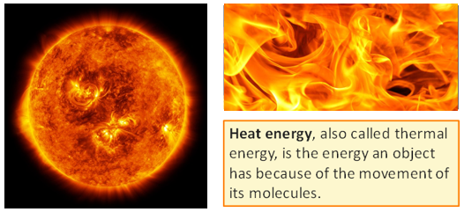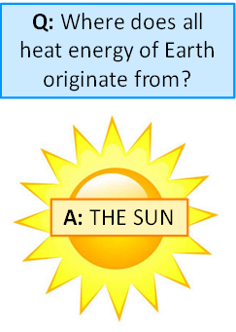

<https://www.quantamagazine.org/what-is-the-sun-made-of-and-when-will-it-die-20180705/>

<https://www.moreechampion.com.au/story/5179605/pilliga-forest-fire-continues-to-burn/>

**ACTIVITY 1:** *Useful & Non-Useful Heat Energy*

Most heat energy is not useful and considered wasted energy. List examples of heat energy that is useful and another list of heat energy that is not useful.

|  |  |
| --- | --- |
| **Useful heat energy** | **Wasted heat energy** |
| *e.g. Hair dryer* | *e.g. heat from laptop* |

**READ:** *Heat, Thermal Energy & Temperature*

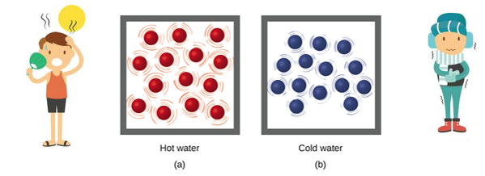

<https://www.123rf.com/photo_99938899_stock-vector-opposite-english-words-cold-and-hot-vector-illustration.html>

<https://courses.lumenlearning.com/suny-chem-atoms-first/chapter/energy-basics/>

* **Hotter substances** have particles that are moving **faster** and are **further apart**.
* 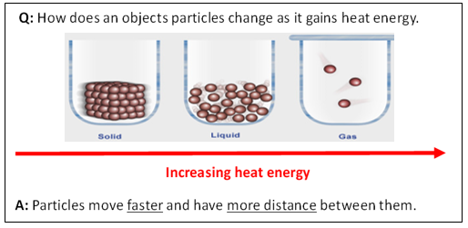**Colder substances** have particles that are moving **slower** and are **closer together.**

<https://www.abc.net.au/science/articles/2010/03/16/2840402.htm>

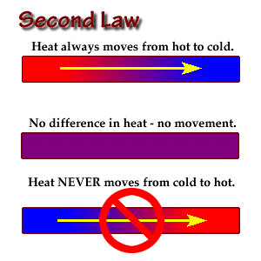 **Heat energy**can be transferred from one object to another.

The transfer or flow due to the difference in temperature between the two objects is called**heat.  
  
Heat Energy Transfer:** Objects with a higher temperature will transfer heat to lower temperature objects.

<http://www.brooklyn.cuny.edu/bc/ahp/MBG/MBG4/BE.SL.02.html>

**ACTIVITY 2:** *Heat on Scholastic*

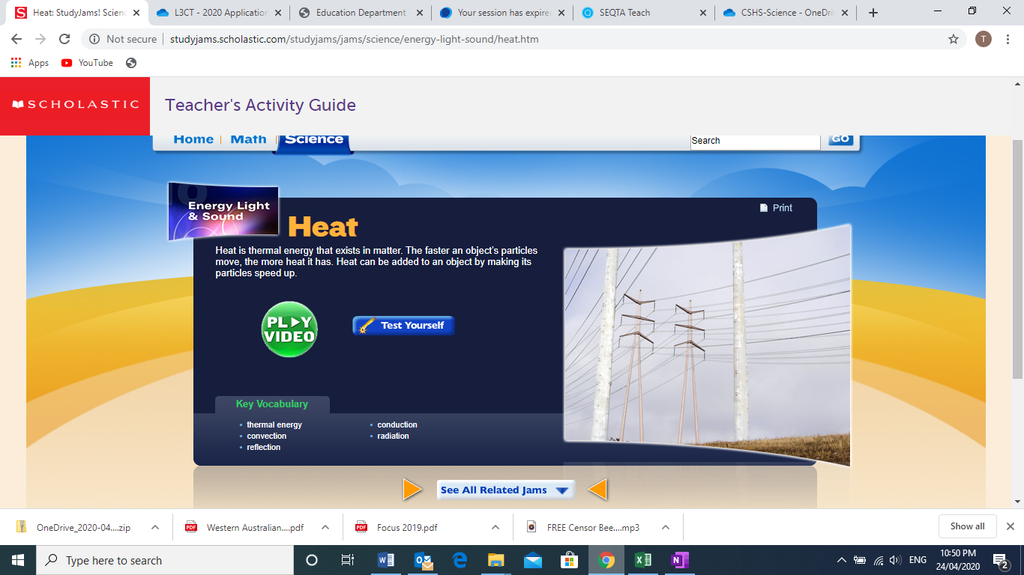

**Image:** <http://studyjams.scholastic.com/studyjams/jams/science/energy-light-sound/heat.htm>

**YOUR TASK:**

1. GO TO: <http://studyjams.scholastic.com/studyjams/jams/science/energy-light-sound/heat.htm>
2. Watch the video about heat from “Scholastic Study Jams”
3. Complete the “Test Yourself” activity provided.

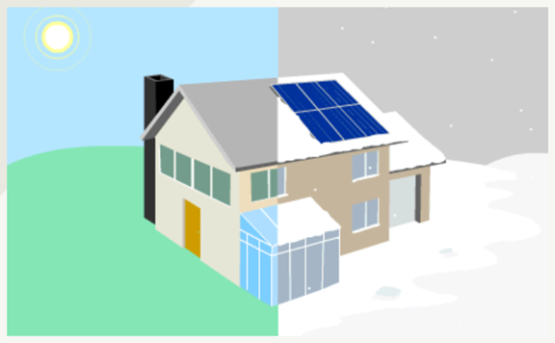**ACTIVITY 3:** *Thermal Energy Transfer*

**GO TO:** <http://pbslm-contrib.s3.amazonaws.com/WGBH/conv16/conv16-int-thermalenergy/index.html#/intro>

**YOUR TASK:** Work through the interactive and answer the questions provided.

**BIG QUESTIONS:**

1. What makes something hot or cold?

|  |
| --- |
|  |
|  |

1. How do things get warmer or cooler?

|  |
| --- |
|  |
|  |

**THE SUN WARMS EARTH:**

1. What keeps our planet at a temperature that can support life?

|  |
| --- |
|  |
|  |

1. Why are some parts of the planet warmer than others?

|  |
| --- |
|  |
|  |

1. How does transfer of thermal energy relate to earthquakes and volcanoes?

|  |
| --- |
|  |
|  |

**AROUND A CAMPFIRE:**

Picture yourself at a campfire. What do you notice?

1. Why might you feel warmer?

|  |
| --- |
|  |

1. What causes the marshmallow to melt?

|  |
| --- |
|  |

1. What should you use to hold the marshmallow over the fire?

|  |
| --- |
|  |

1. Why does smoke rise from the fire?

|  |
| --- |
|  |

**STAYING COOL ON A HOT DAY:**

1. What kinds of floor surfaces feel more comfortable?

|  |
| --- |
|  |

1. How does your body react to the heat?

|  |
| --- |
|  |

1. Where can you go to cool off?

|  |
| --- |
|  |

**SOLAR ENERGY IN YOUR HOME:**

1. How can your house be designed to take advantage of the ways that thermal energy is transferred?

|  |
| --- |
|  |

**ACTIVITY 4:** *Heat vs. Temperature*

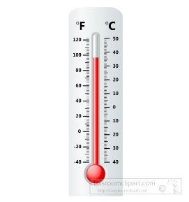**YOUR TASK:** Learn about heat vs. temperature by reading the text below and using the word bank to fill in the missing information.

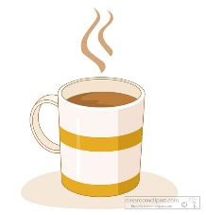Heat and temperature are not the same! Temperature is a measure of how _______ or ________ something is. It is measured in degrees ____________ (oC) .For example: the temperature of ____________ water is 100oC and the temperature that water _____________ at is 0oC.

 Heat is the amount of ________ energy something has. It is measured in _______ (J). The amount of thermal energy depends on the ________ energy of its particles. The faster the _________ move the more thermal energy it has.

Heat vs Temperature of a sparkler

* The tiny sparks are at a very high _________________ .
* Each particle in the spark is ___________________ a lot because it is very hot.
* But as there are not many _______________, the total amount of heat energy is ______________ .

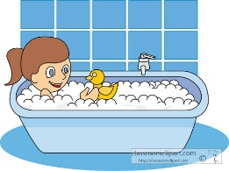Heat vs temperature of a warm bath  
The water is at a _______________ temperature than the sparkler but it contains more heat _______________. This is because it contains more ___________. Each particle is vibrating ____________ as it is at a lower temperature BUT because there are so ______________ - there is more ______________ energy.

Images: <https://classroomclipart.com>

***WORD BANK:***

***celsius lower thermal joules many freezes***

***particles kinetic less cold smaller boiling***

***energy vibrating temperature hot***

**END OF WEEK TEST:** *Heat (Thermal)**Energy*  
**Question 1**List five examples of heat (thermal) energy.

|  |  |
| --- | --- |
| **1** |  |
| **2** |  |
| **3** |  |
| **4** |  |
| **5** |  |

**Question 2**Some sound energy is useful. Some sound energy is not useful and considered wasted energy. List five (5) examples of sound energy that is useful and another five (5) examples of sound energy that is not useful.

|  |  |  |
| --- | --- | --- |
|  | **Useful heat energy** | **Wasted heat energy** |
| **E.g.** | *The radio in a car* | *The engine sound in a car* |
| **1** |  |  |
| **2** |  |  |
| **3** |  |  |
| **4** |  |  |
| **5** |  |  |

**Question 3**

Jason’s mum has always told him*, “Close the door – you are letting the cold air in”.* Is Jason’s mum’s statement correct or incorrect in terms of heat transfer? Explain your answer.

|  |
| --- |
|  |

Rate your understanding of heat (thermal) energy:  
 